Farmer Plus
Requirements Specification Document

27/12/2010
FAST – NUCES

Project Advisor
Sir. Waqar Ahmed

Project Team
Qasim Ifzal – L080969
Amber Shahid – L095061
Tahir Rauf – L095068
Muhammad Zubair – L080808

Revision History

Date | Version | Description | Author
<27/11/2010> | <1.0> | <Initiation of the document> | Syed Qasim Ifzal
<15/11/2010> | <1.1> | <First Review> | Syed Qasim Ifzal  Amber Shahid
<27/12/2010> | <1.2> | <Final Review> | Syed Qasim Ifzal  Amber Shahid  Muhammad Zubair  Tahir rauf

Table of Contents
1. Introduction 4
1.1 Purpose 4
1.2 Scope 4
2. Overview 4
3. Process Flow 5
4. Business Requirements 6
5. User Requirements 7
6. Process Flow with Profiling 8
7. Functional Requirements 9
7.1 Service Design 9
7.2 Requirements Analysis 10
7.2.1 IVR 10
7.2.2 SMS 13
7.2.3 Content Manager 16
8. Traceability Matrix 20
9. High Level Conceptual Diagram 21
10. Non-Functional Requirements 22
11. Hardware Requirements 22
12. Software requirements 22
13. Screens and Voice Menus 22
14. List of Tables and Figures 23

Software Requirements Specification

Introduction

Although Agriculture Industry is a large part of Pakistan’s economy, not much research has been done in providing up to date information & facilities to the farmers working in this sector in every corner of Pakistan. Therefore, we will develop an SMS (Short Message Service) & IVR (Interactive Voice Response) facility system that will provide our farmers ready information (e.g. Hourly weather forecast, Weekly weather forecast, Temperature, Precipitation, Humidity etc.) whenever they need it.

Purpose

This document discusses detailed requirements of Farmer+ system which will be used as basis for the design. The purpose of this document is to enable application architects and software developers to understand required functionalities of the system and develop a viable solution. Business, User, Functional & Non-Functional Requirements will be covered in this document.

Scope

This document explains the basic flow of the system, all types of requirements of the system to be developed, use cases, traceability matrix and relevant diagrams.

Overview

Pakistan's principal natural resources are arable land and water. About 25% of Pakistan's total land area is under cultivation and is watered by one of the largest irrigation systems in the world. Agriculture accounts for about 23% of GDP and employs about 44% of the labor force.
Since the agriculture industry is a major part of Pakistan’s economy; up to date information needs to be provided to farmers where ever they may be present. Computers are one option for accessing information provided either on a CD or via the Internet. But computers are not always readily accessible by small-scale farmers and most of our farmers are not computer literate as well. Web-based mobile phones with Internet access provide another option but, again, not many farmers have such phones or Internet connectivity.

However, one alternative is available to many small-scale farmers: mobile phones with SMS (short message service) capability. With such mobile phones, text messaging and call centers are options for getting information to farmers. Another way to reach many farmers with mobile phones is through interactive voice response (IVR). With IVR, a farmer calls a phone number with a voice recording that presents a menu of questions about the farmer’s rice field and growing conditions. The farmer answers each question by pressing an appropriate number on the keypad. Once all questions are answered, the farmer receives a text message with a guideline on the amounts, sources, and timings of fertilizer application for his or her specific field.

Since not much research or work has been done in this field in Pakistan, we plan to provide substantial help to the farmers via this SMS & IVR system to produce more food with higher profitability.

Process Flow

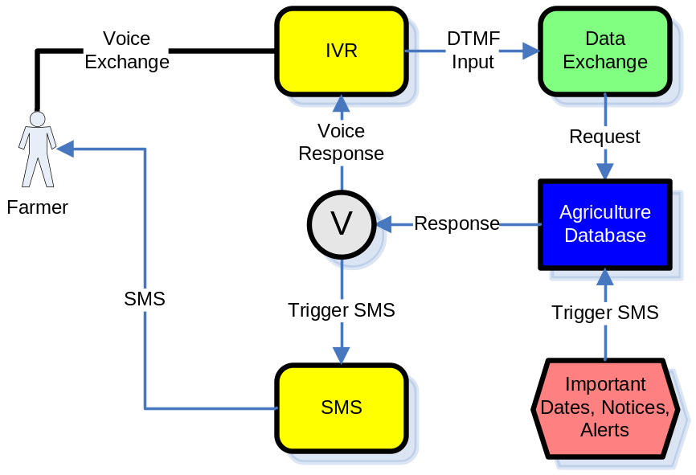

Business Requirements

TABLE 1: Business Requirements
Ref | Requirement
B1 | Develop a system to access accurate, up-to-date & timely information, via SMS & IVR, to assist farmers in decision making.
B2 | Information services and facilities provided by the system should include:  - Price Information  - Weather Information  - Advisory Information  - Complaint  - Warnings
B3 | System should have two types of SMS services:  - Push-type SMS are sent without request  - Pull-type SMS are sent on the user’s request by SMS
B4 | System should have two types of IVR services:  - Push-type IVRs are sent without request  - Pull-type IVRs are sent on the user’s request as a talkie
B5 | System should provide localized access to information and services
B6 | The developed system shall be easily usable by the farmers of Pakistan.

User Requirements
Based on the usability study (Style Guide), the users are divided into two groups based on their language and device usage skills
- Novice – (Typing, Reading and listening skills falling in Low and Medium Categories of User Profiles)
- Expert – (Typing, Reading and listening skills falling in High Categories of User Profiles)
Ref | Requirement
U1 | User shall have access to services related with the following features:  - Price  - Weather  - Complaints  - Advisory  - Warning
U2 | User shall be able to make a call on easy to remember Farmer+ help line number.
U3 | No voice menu shall be longer than 6 options.
U4 | User shall be able to exit from any voice menu by pressing one and the same key every time
U5 | Voice menu shall be in Punjabi
U6 | User shall be able to clearly hear a talkie message on cell phone.
U7 | User shall give feedback on voice menu via DTMF based on the choices available.
U8 | User shall be able to record a message in case none of the offered menus satisfy the request. This shall be later used as service improvement indicator
U9 | User shall be able to send an SMS on the Farmer+ Help Line number when a need arises.  - Expert – Service Requested via a Message Format (e.g: P C wheat, P S wheat)  - Novice – Interactive SMS (e.g: user presses 1 and sends message then a Menu is sent back and interaction continues)
U 10 | Weather Services shall be pulled via SMS with one digit service identification number
U11 | User shall be able to clearly read an SMS from the Farmer+ Help Line number.
U12 | The SMS shall not be preferably longer than 5 lines.
U12 | SMS shall be in Urdu with numerals in English

Process Flow with Profiling
There are two types of profiling done in the application
- User profiling – (Novice and Expert users accessing the system via SMS/IVR)
- Data Profiling – (Each location is a profile itself having its own distinct set of crops, cultivation time, prices etc)
The following diagram depicts how the system intends to combine the two. The example given is to elaborate the process of service access, the scope of the application, however, is much wider.
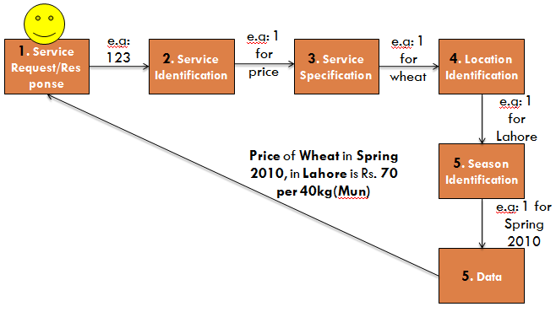
FIGURE 1: Farmer Plus – WITHOUT PROFILING (e:g – [Price] of [Wheat] in [Lahore] in [Spring] [2010])

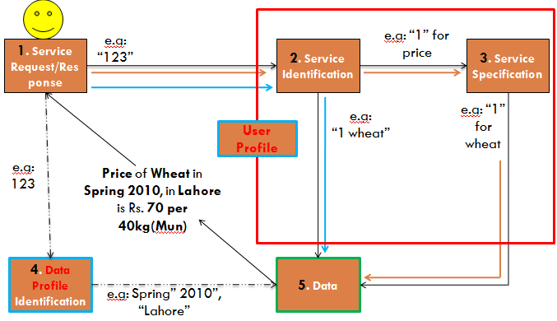

FIGURE 2: Farmer Plus – WITH PROFILING (e:g – [Price] of [Wheat] in [Lahore] in [Spring] [2010])

Functional Requirements
The functional requirements are divided into four service categories
- IVR – Push (IP)
- IVR – Pull (IL)
- SMS – Push (SP)
- SMS – Pull (SL)
- Content Manager

Service Design
The services and the corresponding features are depicted in the following table.

Feature Category | Feature ID | Feature | Service
Price | PRF1 | Crop | IP | IL | SP | SL
Price | PRF2 | Pesticides |  | IL
Price | PRF3 | Fertilizers |  | IL
Price | PRF4 | Seeds | IP | IL |  | SL
Price | PRF5 | Agri-Equipment |  | IL
Weather | WTF1 | Day |  | IL |  | SL
Weather | WTF2 | Week |  | IL |  | SL
Complaints | CMF1 | Delayed Purchasing |  | IL |  | SL
Complaints | CMF2 | Unfair Pricing |  | IL |  | SL
Complaints | CMF3 | Adulteration of Pesticides |  | IL |  | SL
Advisory | ADF1 | Crop Cultivation | IP | IL | SP
Advisory | ADF2 | New Market Items | IP |  | SP
Warning | WRF1 | Weather | IP |  | SP
Warning | WRF2 | Pests | IP |  | SP
Warning | WRF3 | Flood | IP |  | SP

TABLE: 3 - Service Design Table

The following section contains the breakdown of features into requirements, their inputs, sources and constraints.

Requirements Analysis

7.2.1 IVR
- The term “Profile” referred as input source is the dynamic, location and season specific data store.
- The term “Calendar” referred as input source is the system calendar integrated with data through Data Engine
- The term “User” referred as input source includes both the Novice and Expert User.

IVR – Push
General Constraints:  - Bandwidth  - Processor Utilization  - Integration of Punjabi with dynamic data |  |  | Measures:  - Minimal Voice Recording,  - Powerful Processors and  - Dedicated Lines for application  - Data Modeling
Price
Ref | Description |  | Input(s) and Source(s) | Specific Constraints
IPF1 | System shall send the price of a crop set by PARCO |  | - Crop name from Profile  - Location from Profile  - Season from Calendar  - Price from Profile | - Recording <=10 sec
IPF2 | System shall send the price of a seed set by PSC |  | - Seed name from Profile  - Location from Profile  - Season from Calendar  - Price from Profile | - Recording <= 10 sec
Advisory
Ref | Description |  | Input(s) and Source(s) | Specific Constraints
IPF3 | System shall send cultivation time duration of a crop |  | - Crop Name from Profile  - Cultivation Time from Crop Calendar | - Recording <= 10 sec
IPF4 | System shall send spray time duration of a crop |  | - Crop name from Profile  - Spray Name from Profile  - Spray time from Spray Calendar | - Recording <= 10 sec
IPF5 | System shall send reaping time duration of a crop |  | - Crop name from Profile  - Reaping time from Crop Calendar | - Recording <= 10 sec
IPF6 | System shall send New Market Item information |  | - Item Name from Manual Recording  - Information message from Manual Recording | - Recording <= 30 sec
Warning
Ref |  | Description | Input(s) and Source(s) | Specific Constraints
IPF7 |  | System shall send warning about flood | - Location from Profile  - Warning issue Instructions from Trigger  - Warning message from Profile | - Recording <= 10 sec
IPF8 |  | System shall send warning about pest | - Pest from Pest Data  - Location from Profile  - Warning issue instructions from Trigger  - Warning message from Profile | - Recording <= 10 sec  - Pest attack % > EIV (Economic Impact Value)
IPF9 |  | System shall send warning about wind | - Location from Weather.com  - Value of weather element from Weather.com  - Warning issue message from Trigger | - Recording <= 10 sec  - Wind value > Threat Level
IPF10 |  | System shall send warning about rain | - Location from Weather.com  - Value of weather element from Weather.com  - Warning issue message from Trigger | - Recording <= 10 sec  - Rain value > Threat Level
IVR – Pull
General Constraints:  - Performance limits for simultaneous calls  - Echo  - Pujnabi Language integration with data  - Short Menus (<=6 options) from Usability Guide |  |  | Measures:  - Support for simultaneous calls within system resources  - Echo suppressing  - Data Modeling  - One option for recording always kept open in case the menu does not provide the desired information  - Message recording length, in case the match is not found in the options is kept at <=30 seconds
Price
Ref |  | Description | Input(s) and Source(s) | Specific Constraints
ILF1 |  | System shall provide support price of crops as set by PARCO | - PARCO price from Profile  - DTMF value from User
ILF2 |  | System shall provide the price information location of a pesticide of top 5 companies as categorized by Agri-Punjab Department | - Pesticide service location from Profile  - Company information from Agri-Punjab Department.  - DTMF value from User
ILF3 |  | System shall provide the company price of a fertilizer | - Price from Profile of the following fertilizers  - DAP  - Nitro-phosphate  - SSP  - Urea  - Potash  - DTMF value from User
ILF4 |  | System Shall provide the price of a seed | - Seed price from Profile  - DTMF value from User
ILF5 |  | System Shall provide the price information location (Service Centers) of top 5 requested agri-equipments | - Equipment Service Center from Profile  - DTMF value from User
Weather
Ref |  | Description | Input(s) and Source(s) | Specific Constraints
ILF6 |  | System shall provide Today’s forecast regarding:  - Rain  - Wind | - Wind data from Weather.com  - Rain data from Weather.com  - DTMF value from User
ILF7 |  | System shall provide Tomorrow’s forecast regarding:  - Rain  - Wind | - Wind data from Weather.com  - Rain data from Weather.com  - DTMF value from User
ILF8 |  | System shall provide the week’s forecast regarding:  - Rain  - Wind | - Wind data from Weather.com  - Rain data from Weather.com  - DTMF value from User | [Removed after Usability Testing]
Complaint
Ref |  | Description | Input(s) and Source(s) | Specific Constraints
ILF9 |  | System shall record complaints about delayed purchasing of reaped crops | - Crops name from Profile  - DTMF value from User
ILF10 |  | System shall record complaints about unfair price of crops of reaped crops | - Crop name from Profile  - DTMF value from User
ILF11 |  | System shall record complaints about adulterated pesticides | - Pesticide name from Profile  - DTMF from User
Advisory
Ref |  | Description | Input(s) and Source(s) | Specific Constraints
ILF12 |  | System shall provide with Cultivation Time of Crop | - Cultivation time from Profile  - DTMF from User
ILF13 |  | System shall provide with Spray Time of Crop | - Spray time from Calendar  - DTMF from User
ILF14 |  | System shall provide with Reaping Time of Crop | - Reaping time from Calendar  - DTMF from User

7.2.2 SMS

SMS – Push
General Constraints:  - Integration of Punjabi with dynamic data  - Language Skills |  | Measures:  - Message Length<=5 lines where possible  - Text in Urdu and numeral in English  - Data Modeling
Price
Ref | Description | Input(s) and Source(s) | Specific Constraints
SPF1 | System shall send the price of a crop set by PARCO | - Crop name from Profile  - Location from Profile  - Season from Calendar  - Price from Profile | - Message with crop name and price only
Advisory
Ref | Description | Input(s) and Source(s) | Specific Constraints
SPF2 | System shall send cultivation time duration of a crop | - Crop Name from Profile  - Cultivation Time from Crop Calendar
SPF3 | System shall send spray time duration of a crop | - Crop name from Profile  - Spray Name from Profile  - Spray time from Spray Calendar
SPF4 | System shall send reaping time duration of a crop | - Crop name from Profile  - Reaping time from Crop Calendar
SPF5 | System shall send New Market Item information | - Item Name from Manual Typing  - Information message from Manual Typing
Warning
Ref | Description | Input(s) and Source(s) | Specific Constraints
SPF6 | System shall send warning about flood | - Location from Profile  - Warning issue Instructions from Trigger  - Warning message from Profile
SPF7 | System shall send warning about pest | - Pest from Pest Data  - Location from Profile  - Warning issue instructions from Trigger  - Warning message from Profile | - Pest attack % > EIV (Economic Impact Value)
SPF8 | System shall send warning about wind | - Location from Weather.com  - Value of weather element from Weather.com  - Warning issue message from Trigger | - Wind value > Threat Level
SPF9 | System shall send warning about rain | - Location from Weather.com  - Value of weather element from Weather.com  - Warning issue message from Trigger | - Rain value > Threat Level
SMS – Pull
General Constraints:  - Integration of Punjabi with dynamic data  - Language Skills of  - Novices and  - Experts |  | Measures:  - Feedback messaging for Novices  - Message formats for experts  - Text in Urdu and numeral in English  - Data Modeling
Price
Ref | Description | Input(s) and Source(s) | Specific Constraints
SLF1 | System shall send the Price menu to a Novice User | - Menu from Menu Data  - Message from User | - Message format:  [ServiceNumber]
SLF2 | System shall send the price of a crop set by PARCO to an Expert User | - PARCO price from Profile  - Message from User | - Message format:  [ServiceNumber CropName in British English]
SLF3 | System shall send the crop menu to a Novice User | - Menu from Menu Data  - Message from User | - Message format:  [ServiceNumber]
SLF4 | System shall send the price of a crop set by PARCO to an Novice User | - PARCO price from Profile  - Message from User | - Message format:  [CropNumber]
SLF5 | System shall send the price of a seed set by PSC to an Expert User | - PSC price from Profile  - Message from User | - Message format:  [ServiceNumber SeedName in British English]
SLF6 | System shall send the seed menu to a Novice User | - Menu from Menu Data  - Message from User | - Message format:  [ServiceNumber]
SLF7 | System shall send the price of a seed set by PSC to an Novice User | - PSC price from Profile  - Message from User | - Message format:  [SeedNumber]
Weather
Ref | Description | Input(s) and Source(s) | Specific Constraints
SLF8 | System shall send the  - Rain and  - Wind  forecast for a day for Expert User | - Rain data from Weather.com  - Wind data from Weather.com  - Message from User | - Message format:  [ServiceNumber DayNumber]  DayNumber  - for Sunday  - for Monday  - for Tuesday  - for Wednesday  - for Thursday  - for Friday  - Saturday
SLF9 | System shall send weather menu to a Novice User | - Menu from Menu Data  - Message from User | - Message format:  [ServiceNumber]
SLF10 | System shall send the  - Rain and  - Wind  forecast for a day for Novice User | - Rain data from Weather.com  - Wind data from Weather.com  - Message from User | - Message format:  [DayNumber]
SLF11 | System shall send the  - Rain and  - Wind  forecast for a week to User | - Rain data from Weather.com  - Wind data from Weather.com  - Message from User | - Message length <= 5 lines will be violated due to the length of data  - Message format:  [ServiceNumber 3]
Complaints
Ref | Description | Input(s) and Source(s) | Specific Constraints
SLF12 | System shall record complaint about delayed purchasing of a crop from an Expert User | - Message from User  - Crop name from Profile | - Message format:  [ServiceNumber CropName in British English]
SLF13 | System shall send Complaint Menu to a Novice User | - Menu from Menu Data  - Message from User | - Message format:  [ServiceNumber]
SLF14 | System shall record complaint about delayed purchasing of a crop from a Novice User | - Message from User  - Crop name from Profile | - Message format:  [CropNumber]
SLF15 | System shall record complaint about unfair pricing of a crop from an Expert User | - Message from User  - Crop name from Profile | - Message format:  [ServiceNumber CropName in British English]
SLF16 | System shall record complaint about Unfair Pricing of a crop from a Novice User | - Message from User  - Crop name from Profile | - Message format:  [CropNumber]
SLF17 | System shall send Pesticides Menu to a User | - Menu from Menu Data  - Message from User | - Message format:  [ServiceNumber]
SLF18 | System shall record complaint about Adulterated Pesticide | - Message from User  - Pesticide from Profile | - Message format:  [PesticideNumber]

7.2.3 Content Manager
- The term “user” in this section refers to the person responsible for the management of application.

Data Engine
General Constraints:  - Integration of Punjabi with dynamic data  - Integration of Urdu with dynamic data  - Integration of Punjabi with dynamic data |  | Measures:  - Data modeling enforced through specific constraints and Measures as defined below.  - Voice for IVR shall be stored in mp3, mp4 or wav format  - System shall set the crop, seed, equipment, fertilizer and pesticide Name in English.  - For SMS Services, System shall set the crop, seed, equipment, fertilizer and pesticide Name in Urdu language font.  - For SMS Services, System shall store price in Arabic Numerals.  - For SMS Services, crop, seed, equipment, fertilizer and pesticide Unit shall be stored in Urdu Language font.  - For IVR, System shall store crop, seed, equipment, fertilizer and pesticide name in Punjabi voice.  - For IVR, System shall store price in Urdu voice Language.  - For IVR Services, crop, seed, equipment, fertilizer and pesticide Unit shall be stored in Urdu voice.
Profile
Ref | Description | Input(s) and Source(s) | Specific Constraints
CMF1 | System shall allow the user to enter Location data | - Area Code from PTCL area codes  - Area Code as per PLMN area codes  - Area Name from PTCL District Codes  - Area Name from PLMN area codes | - Area Code shall be inserted in Arabic Numerals Characters.  - Area Name shall be written in English Characters.  - For SMS Services Area Name shall be stored using Urdu language font.  - For IVR Services Area Name shall be stored in Punjabi Voice Language.
CMF2 | System shall allow the user to enter Crop data | - Crop name from PARCO  - Crop Price from PARCO
CMF3 | System shall allow the user to enter Spray data | - Pesticide name from Company data  - Service Center Location from Company Data
CMF4 | System shall allow the user to enter Seed data | - Seed name from PSC Data manual  - Seed Price from PSC Data manual
CMF5 | System shall allow the user to enter Fertilizer data | - Fertilizer name from Agri Punjab  - Fertilizer Price from Agri Punjab
CMF6 | System shall allow the user to enter Agri-Equipment data | - Equipment Name from Company Data  - Equipment Price from Company Data
CMF7 | System shall allow the user to enter Warning data | - Type (rain, wind) from Weather Service manager  - Type (pest, flood) from User  - Severity (rain, wind) from Weather Service manager  - Severity (pest, flood) from User  - Suggestion from User
Scheduler
Ref | Description | Input(s) and Source(s) | Specific Constraints
CMF8 | System shall allow the user to set up Calendar Events | - System Calendar  - Event Schedule  - Event Description  - Cultivation Period  - Reaping Period  - Spray Period  - Market Item Info | - English Short Date format (dd/mm/yyyy) e.g:- 24/12/2010  - Date shall be stored in ‘short Date format’ in English characters.  - For SMS, Season shall be stored in Urdu Language font.  - For IVR Season shall be stored in Urdu Voice Language.  - For IVR, Month from Calendar shall be stored in Urdu Voice Language.  - For IVR, Date from Calendar shall be stored in Urdu Voice Language  - For IVR, Year from Calendar shall be stored in Urdu Voice Language
Complaint Manager
Ref | Description | Input(s) and Source(s) | Specific Constraints
CMF9 | System Shall allow the complaints to be recorded | - Caller ID from CLI  - Complaint message | IVR recording<=30 sec
CMF10 | System Shall allow the complaints to be logged | - Complaint ID  - Recommendation
Marketing Manager
Ref | Description | Input(s) and Source(s) | Specific Constraints
CMF11 | System Shall allow the user to enter new market item information | - Item Code  - Item Name  - Item Price  - Description  - Push Type(IVR/SMS)  - Period | - IVR recording<=10 sec  - SMS<=5 lines
CMF12 | System Shall allow the user to edit new market item information | - Item Code  - Edit detail
Web Services Management
Ref | Description | Input(s) and Source(s) | Specific Constraints
CMF13 | System shall allow the user to specify mapping criteria for Web Services Data | - Mapping Criteria from Experts  - Web Services Data from Web Services including:  - Wind  - Rain

Traceability Matrix
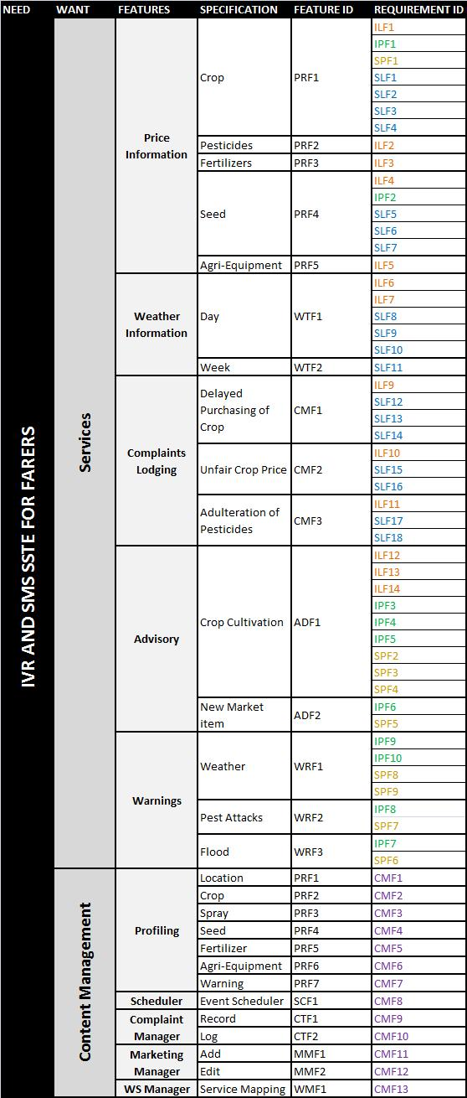
TABLE 4: Traceability Matrix

High Level Conceptual Diagram
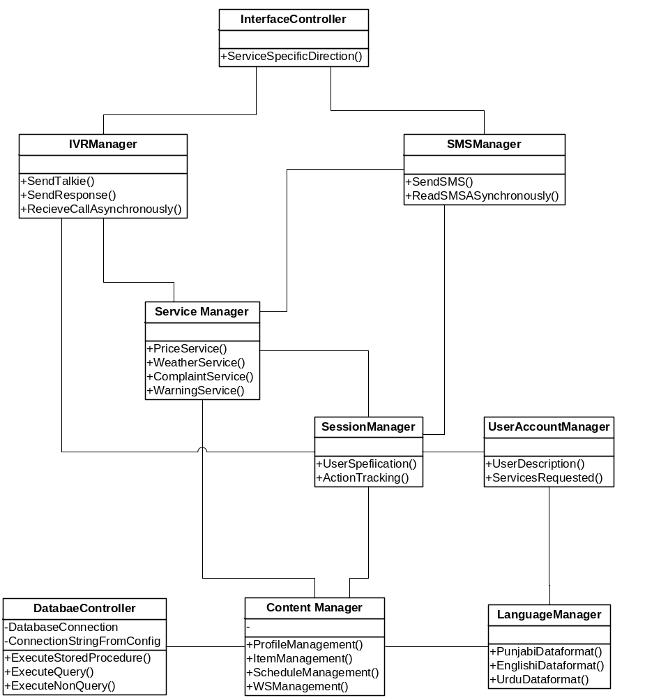

FIGURE 3: High Level Conceptual Model

Non-Functional Requirements

- The System shall be user friendly with respect to the specifications in Style guide.

- The system shall be available 24 hours a day, seven days a week.

- The information provided by the system shall be accurate

- The information provided by the system shall be reliable
- The turnaround time for SMS – pull shall be less than or equal to 20 seconds, assuming no network latency

- Response time of the first level voice menu for IVR – Pull Service shall be less than or equal to 5 second, assuming no network problem

Hardware Requirements

- 1 Mobile GSM device

- 1 FXO Gateway (4 port)

- 4 Computer machines (With UPS)

- 1 Network Switch & 8 Network Cables

Software requirements

- MS Project (Project Management)

- .Net 3.0 Framework (Development Environment)

- Web SVN (Configuration management)

- Testlink (Testing)

- Asterisk (SoftPBX)

- TrixBox (Wrapper for configuration of Asterisk)

- SMSLib (SMS Management)

Screens and Voice Menus
[Refer “Style Guide” document]

List of Tables and Figures

Sr No | Reference | Description
1 | Table 1 | Business requirements
2 | Table 2 | User Requirements
3 | Table 3 | Service Design
4 | Table 4 | Traceability Matrix
5 | Figure 1 | Process Flow with profiling
6 | Figure 2 | Process Flow without profiling
7 | Figure 3 | High Level Conceptual Diagram

